Data Linkage & Pseudonymisation Tool (DLPT)

Site Staff Guide
Adapted for the [TRIAL NAME] Trial

If you encounter any problems while following the instructions below, please contact [CONTACT DETAILS].

Name of trial or study: | [TRIAL NAME]
Adapted guide version: | [FILE NAME]
For use with adapted DLPT version: | [DLPT FILE NAME]

Introduction to the DLPT

The DLPT is a macro-enabled Excel file which is designed to process data exported from trial site patient management software. It has three main functions:
- Linkage of exported data with records held in the trial database held by [INSTITUTION NAME].
- Pseudonymisation (de-identification) of exported data at site, prior to transfer to [INSTITUTION NAME]
The tool therefore allows clinical records to be linked with those of consented trial participants, while pseudonymising the data for those patients who have not consented to the trial, and whose data can therefore only be used in a de-identified format for research purposes.

Adaptation to [TRIAL NAME]

The DLPT has been adapted to [TRIAL NAME] in the following ways:

[TRIAL NAME] Data Linkage and Pseudonymisation Flow Diagram:

[INSERT DIAGRAM]

Using the DLPT

Downloading existing patient record IDs from REDCap
In this first step, you will be downloading a list of patients who have given consent to provide clinical data to [INSTITUTION NAME] in a fully identifiable format, including their [IDENTIFIER].
- Log in to REDCap: [LINK]
- Click on My Projects to view the projects you have access to:
- Click on the project ‘[PROJECT NAME]’
- On the left hand menu, click on the report ‘[REPORT NAME]’
[SCREENSHOT]

- You will see a list of identifiers and record IDs. Click on ‘Export Data’.
[SCREENSHOT]

- In the box that appears, select ‘CSV / Microsoft Excel (raw data)’ under ‘Choose export format’, then click ‘Export Data’.
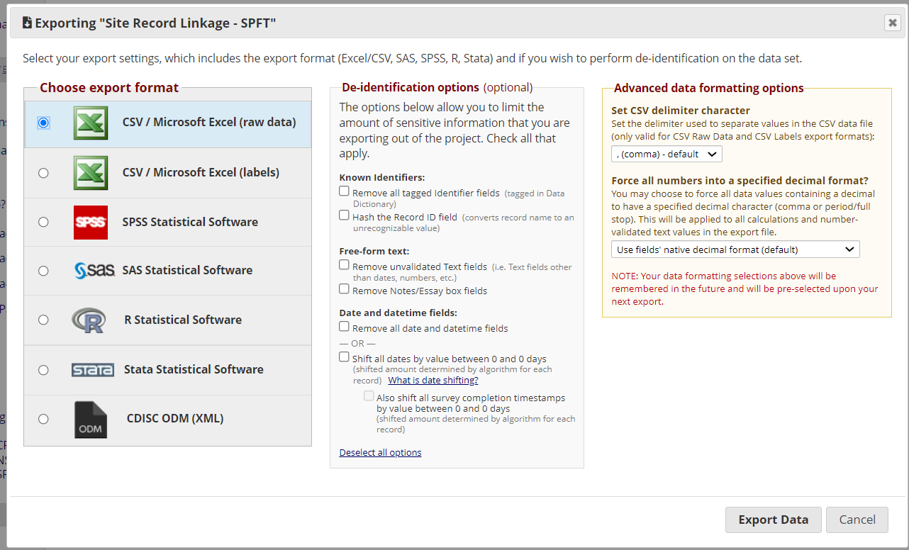

- The following box will appear:
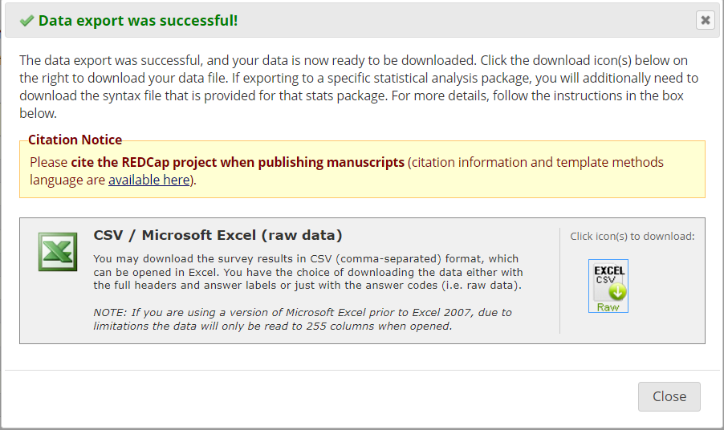
Click on the ‘Excel csv’ icon to download the file.
Choose a suitable location to download the file to, and open it when the download is complete.

2.2 Preparing the DLPT

- Save the DLPT xlsm file in an appropriate location (bearing in mind it will be processing identifiable patient data), and open it.
- As the file contains macros, you may see the following warnings. Click ‘Enable Content’, click ‘Yes’ to make the file a trusted document etc.
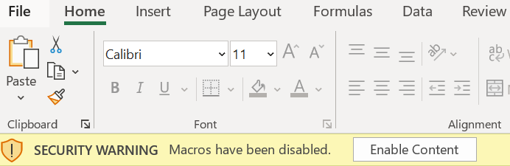

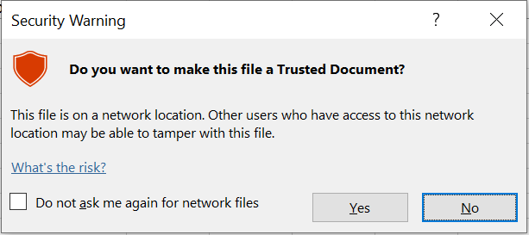
Depending on your organisation’s security settings, you may need to create a new trusted location in which to save the file (See https://support.microsoft.com/en-us/office/add-remove-or-change-a-trusted-location-7ee1cdc2-483e-4cbb-bcb3-4e7c67147fb4 ) or request permissions from your IT support.

- The file contains three sheets: ‘Source data’, ‘Processed data’ and ‘User’. Go to ‘User’. This is where you will paste the list of identifiers and record IDs you exported from REDCap.

Going back to the REDCap export file, select ONLY the first two columns of data ([FIELD NAMES), without the headers, as shown below. Ctrl-C to copy.
[SCREENSHOT]
- Back in the DLPT file, on the sheet ‘User’, paste this data as shown below:

[SCREENSHOT]

- Go to the ‘Source data’ sheet. This is where you need to paste the clinical data exported from [DATA SOURCE].
Note: the top row (header) is protected – please paste the clinical data without headers from row 2.
[SCREENSHOT]
The headers should match the data.
- Go back to the User tab and click ‘Run’.
When the processing is complete (this should take less than 1 minute), you will see the following pop-up:
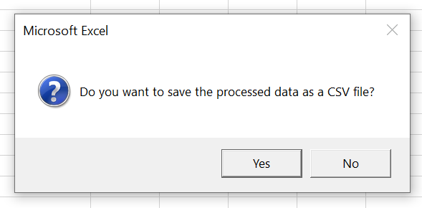
Click yes to save the de-identified data as a csv file.
- Finally, upload the CSV file to [LOCATION], and email [EMAIL] to notify us that you have completed the upload.

